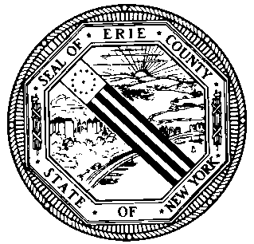 |  | THE ERIE COUNTY LEGISLATURE  HEALTH &  HUMAN SERVICES  COMMITTEE |  |  | Thomas J. Mazur  Chair  Timothy R. Hogues  Vice-Chair  Paul P. Henderson  Clerk
 |  |  | Meeting No. 8 – May 14, 2013 – 9:00 AM
 |  |  |  |  | TAB | R&F | APP
1. | INTRO 10-1 (2012)  Session 10 |  |  | HOGUES  “Expressing Support for NYS Assembly Bill A. 9601-A/NYS Senate Bill S. 6085-A to Limit Direct Access to OTC Medicine Containing Dextromethorphan”
2. | INTRO 10-3 (2012)  Session 10 |  |  | LORIGO, RATH & HARDWICK  “Supporting Prevention of Illicit Drug Use by Social Service Recipients”
3. | COMM. 23M-3 (2012)  Session 23 |  |  | LIGHTHOUSE MEDICAL CLINIC  “Description of Organization Concerning Funding Request”
4. | INTRO 5-1 (2013)  Session 5 |  |  | MARINELLI  “Recognizing Women's History Month by Supporting Governor Cuomo's Women's Equality Agenda”
5. | COMM. 7M-2 (2013)  Session 7 |  |  | YOUNG CITIZENS FOR ECC  “E-Mail Transmission to Chair of Legislature Concerning the Future of Compass East”
6. | COMM. 9M-4 (2013)  Session 9 |  |  | NIKE, MAY 2013  “Article Titled, "An Analysis of Governor Cuomo's 10-Point Women's Equality Act"”

