PEACE, LOVE, YARN-A-THON
SATURDAY, NOVEMBER 1st FROM 11 - 4
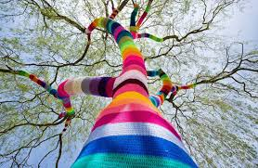
KNIT & CROCHET WITH FRIENDS FROM 11 – 4.
FOR EVERY 15 MINUTES YOU KNIT/CROCHET YOU EARN AN ENTRY INTO OUR RAFFLE.
ALL KNIT/CROCHET PROJECTS ARE BEGINNER-FRIENDLY.
OUR CURRENT PROJECT IS CHRISTMAS ORNAMENTS WHICH WILL BE DONATED TO THE NEWSTEAD FOOD PANTRY.
PLEASE BRING A DONATION OF A NONPERISHABLE FOOD ITEM FOR THE NEWSTEAD FOOD PANTRY.
WE WILL ALSO BE HAVING A BAKE SALE TO BENEFIT THE NEWSTEAD FOOD PANTRY!
PLEASE BRING YOUR OWN NEEDLE OR HOOK IF POSSIBLE ; SOME YARN WILL BE AVAILABLE.

