Sardinia Town Pool
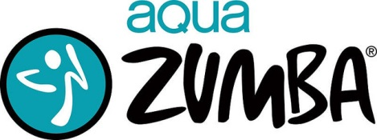

Mondays
7:15 pm – 8:00 pm
$5.00 per class

Instructor: Anne Dixon “Zumba Anne”
Class Dates: July 13, 20, 27
August 3, 10, 17
Check if you are a Sardinia resident | Name | Phone Number

Make Checks/Money Orders
Payable to: Town of Sardinia

Aqua Zumba – Pay All At Once ($35) $ _______
Aqua Zumba – Pay As I Go ($5) $________
Check #________
Receipt #________

*This form only needs to be filled out once and brought to your first class*

