Sardinia Veterans Park 2018
13169 Genesee Road, Sardinia, NY
MUSIC in the PARK

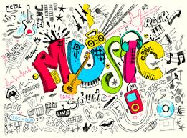

ALL SHOWS START AT 6:00 pm – 8:00 pm
EVERY TUESDAY FOR SIX WEEKS

July 10th ROGER HILL

JULY 17TH “ELVIS” PATRICK JOHNSON

JULY 24TH ROSE WAGNER & THE SPENCER FAMILY BAND

JULY 31ST GENE HILTS & RUSTIC RAMBLERS

AUGUST 7TH PAUL ZITTLE & PURE COUNTRY

AUGUST 14TH DAVE TUCKER & NIP & TUCK

Refreshments By: Sardinia Methodist Church and Chaffee Baptist Church

Sponsored by: The Sardinia Town Board
Information Call Councilman – Len Hochadel 716-496-9853

