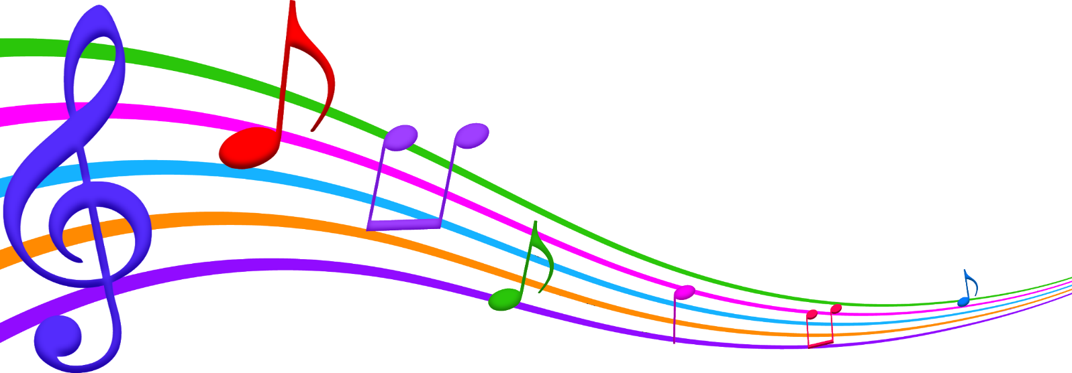

**Music in the Park**

**2019**

**13169 Genesee Road, Sardinia NY – Veterans Park**

**All shows 6:00pm – 8:00pm**

*Every Tuesday for 7 weeks Rain or Shine*

**July 9th ROGER HILL**

*Refreshments by Sardinia Methodist Church*

**July 16th GENE HILTS - RUSTIC RAMBLERS**

*Refreshments by Sardinia Methodist Church*

**July 23rd PAUL ZITTLE - PURE COUNTRY**

*Refreshments by Chaffee Baptist Church*

**July 30th DAVE TUCKER - NIP & TUCK**

*Refreshments by Chaffee Baptist Church*

**Aug 6th PATRICK JOHNSON – ELVIS**

*Refreshments by Protection Methodist Church*

**Aug 13th ONE SONG – RON & NANCY**

*Refreshments by Protection Methodist Church*

**Aug 20th ROSE WAGNER & KEN SPENCER FAMILY BAND**

*Refreshments by Sardinia Historical Society*

For further information or questions call - Lenny Hochadel 716-496-9853 or

Beverly Gambino 716-496-7225 or Town Hall 716-496-8900