

**FALL 2017**

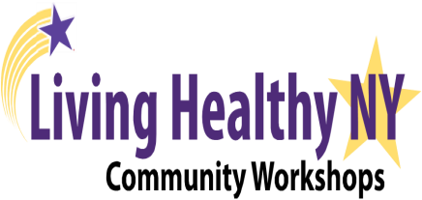

**Erie County Senior Services**

Mark Poloncarz, County Executive Timothy R. Hogues, Commissioner



**Register Today to attend a FREE**

6-Week Living Healthy Workshop

* **Please Sign Up at the Site OR**
* **Call**: The Erie County Senior Servicesat: **(716) 858-8526 OR**
* **Register online: www.ceacw.org**

**The Living Healthy Self-Management Program**

**is for YOU if**:

* You Have:
  + **Diabetes**
  + **Arthritis, Chronic Pain**
  + **Heart, Lung, Breathing concerns**
  + **A loved one with a chronic condition**
  + **Depression, Mental health concerns**
  + **Any on-going health concern**
* You want to **Lose Weight**
* **You are ready to Put Life Into Your Life**!

**Living Healthy Diabetes**

**Self-Management Program**

**Amherst Senior Center**

370 John James Audubon Pkwy, Amherst, NY 14228

Fridays: October 6 – November 17

Time: 9:30 AM- 12:00 PM

**Town of Tonawanda Senior Center**

291 Ensminger Rd, Tonawanda, NY 14150

Fridays: October 6 – November 17

Time: 1:00 PM – 3:30 PM

**Hamburg Senior Center**

4540 Southwestern Blvd., Hamburg, NY 14075

Tuesdays: October 17 – November 21

Time: 9:30 AM – 12:00 PM

**Town of Aurora Senior Center**

101 King St, Suite A, East Aurora, NY 14052

Mondays: October 23 – November 27

Time: 9:30 AM- 12:00 PM

**Clarence Senior Center**

4600 Thompson RD, Clarence, NY 14031

Wednesdays: October 25 – November 29

Time: 9:30 AM – 12:00 PM

**Living Healthy Chronic Disease**

**Self-Management Program**

***For help with on-going health concerns***

**West Seneca Senior Center**

**4620 Seneca St., West Seneca, NY 14224**

**Thursdays: October 5 – November 9, 2017  
Time: 9:45 – 12:15 PM**

**Schiller Park Senior Center**

**2057 Genesee St., Buffalo, NY 14211**

Tuesdays: October 10 – November 14, 2017

Time: 9:30 AM-12:00 PM

**Essential Solutions**

34 Patrick Ln. Depew**,** NY 14043

Mondays: November 6 – December 11, 2017

Time: 9:00 AM – 11:30 AM

Ese

**Register Today!**