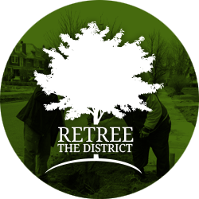
NOVEMBER ONE-TIME OPPORTUNITES

There are many benefits to planting trees. Trees clean the air, prevent soil erosion, provide food for wildlife and are great for children to play on and learn from! The University Heights Collaboration is seeking YOUR help to plant 215 trees on Sat., Nov. 5th If you are familiar with planting trees, you can help lead a group or simply join a planting group. Help is also needed with registration, refreshments, and directions!

To Register please call 858-7548 by Fri. 10/28.
Volunteers will meet at 147 Diefendorf Hall on UB’s South Campus at 9AM on Saturday, November 5th. Refreshments will be provided in the morning and afternoon.

WNY Food Bank
Operation: Rock Out Hunger
November 16-23, 2016
Eastern Hills Mall
https://www.surveymonkey.com/r/8DLDJH9

For the 11th year, DJ Jickster will live on a tractor trailer for a week, collecting food and funds to benefit the Food Bank of WNY. We are in need of volunteers to help collect donations!
Volunteers assist DJ Jickster by collecting donations from those who come and donate. This means you will be helping remove food from donors’ cars, accepting donated money and putting it on the truck.

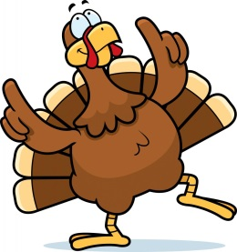
Buffalo City Mission Turkey Express
Looking for a way that you can give back this Thanksgiving holiday?
For over 20 years, Turkey Express has been serving those in need in WNY by providing home-cooked Thanksgiving meals. In correlation with Meals on Wheels of WNY, the Buffalo City Mission is able to deliver over 5,500 meals each Thanksgiving to individuals who either cannot make meals for themselves, or do not have the funds to do so. Here at the Mission, it is our goal to show the love of Jesus Christ to the homeless and hurting in Western New York, and we take part in doing so to those outside of our facility during our Turkey Express event.
Call (716) 854-8181 x419 as opportunities fill up quickly for this event.
Telephone Receptionists
This volunteer opportunity is for individuals who would like to help schedule incoming call requests for the delivery of meals to those in need in the community. Receptionists are needed during the weeks of November 7th and 14th between the hours of 9:30AM and 3:30PM.

Delivery Teams
This volunteer opportunity is for individuals or groups who would like to help deliver meals to the community on Thanksgiving Day. Every 15 minutes between the hours of 8AM and 12PM, teams will be deployed, delivering a total of 5,500 meals. Bring a friend and/or family member and join us in this time of giving.

Kitchen Prep
On November 21st, 22nd, and 23rd, Kitchen Prep volunteers are needed to help prepare food for our assembly and delivery teams to bring Thanksgiving meals to those in need in our community on Thanksgiving day.

Meal Assembly Teams
Volunteers are needed on the morning of Thanksgiving day from 7:30AM to 10:30AM to help assemble takeout trays and bags for the delivery teams during Turkey Express. This will consist of plating and assembling prepared, portioned food and preparing bags with the necessary materials required to help deliver a full Thanksgiving meal to someone in need.

Decorators
Bring joy to our community by helping to decorate the 600 bags that will be needed this Thanksgiving for Turkey Express. If you enjoy coloring, this is just for you! What a simple but great way to impact someone’s life this Thanksgiving season!

