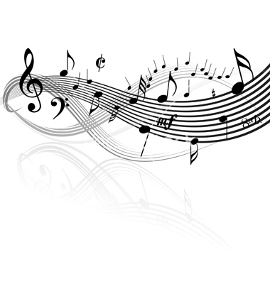
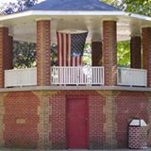
Concerts in the
Park Series

July 7 – Akron Community Band
marches, show tunes, novelty numbers
July 13 – Frank Sinatra Tribute
July 20 – West of the Mark
Western New York's Favorite Country Band
July 27 – Hit and Run
Buffalo’s premiere party band
August 3 – Johnny Smoke
Real Rock Music
August 10 – Akron Community Band
marches, show tunes, novelty numbers
August 17 – Terry Buchwald
A tribute to the king
August 24 – To be announced
Alden Firemen’s Bandstand Park, Broadway & Church St.
7:30 pm start time, bring your own lawn chairs.

