Town of Alden
April Newsletter
Editor: Bill Sivecz
william.p.sivecz@erie.gov
Website: www.alden.erie.gov

From Supervisor Rick Savage’s Desk
Welcome to “Spring” although we can’t really tell from the weather we have been experiencing in March. I imagine the Robins think they made a wrong turn on their migration. Hopefully, April will warm up some.
I take my hat off to all Town employees who continue to work hard and use taxpayer’s dollars judiciously. All Department Heads continue to look for ways to save money and do things more efficiently. Sewer District 2’s (Alaura Drive) new sewage treatment plant has been designed, and once approved by NYSDEC and NYSEFC, we will be able to solicit bids. Our intention is to have it built in the coming construction season. The Senior/Community Center large room has been painted and the kitchen remodeled.
Over the past year, the Town Board, Town Attorney, and Department Heads have reviewed the Town Codes in their entirety. We will have a public hearing on April 16, 2018, at 7:05 pm to discuss the changes and code format.
Now I have to talk trash- just so you know as my office receives quite a few questions-
Our 3 year refuse contract which was took effect with Modern Disposal in January 2015 specifies that residents can put out four containers no larger than 30 gallons per week of mixed municipal waste and one bulky item per week. Construction debris is specifically prohibited in the contract.
Don’t forget to recycle!
Alden History Quiz
When was the community of Alden was first settled?
a.} 1823
b.) 1810
c.) 1804
{Answer on back page}

Sandridge Slow Down
Alden NASCAR drivers take heed! The speed limit on Sandridge has been lowered. With residents’ safety concerns Erie County Highway Department.
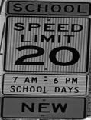
The County agreed to lower the speed limit to 30 mph. The speed limit reduction runs from Broadway to the Sandridge/North Road intersection. Additionally the area around St. John’s Church and School {approximately from the Church parking lot to GDI Countryside Inn}, has been reduced to 20 mph.
Drive Safe, Slow Down

Spring has sprung,
Brush pickup has begun
Spring is here, {no, it really is}. With its arrival the Town Highway has returned to picking up brush on a regular basis during the months of April through November.
During the first week of the month brush is picked up for properties on the North side of Broadway and on the third week of the month, brush is picked up for properties on the South side of Broadway.
Brush should be out on Monday mornings by 6:30am, NO return trips will be made. All brush should be piled no more than three feet high with cut ends facing the road. No limbs over ten inches in diameter will be picked up.

Electronic Recycling

Due to higher disposal costs, we are forced to limit TV drop offs to 3 TVs per address, per year. You must be a Town of Alden resident. Reminder, no appliances with refrigerant, such as, dehumidifiers, window air conditioners, etc. can be accepted.

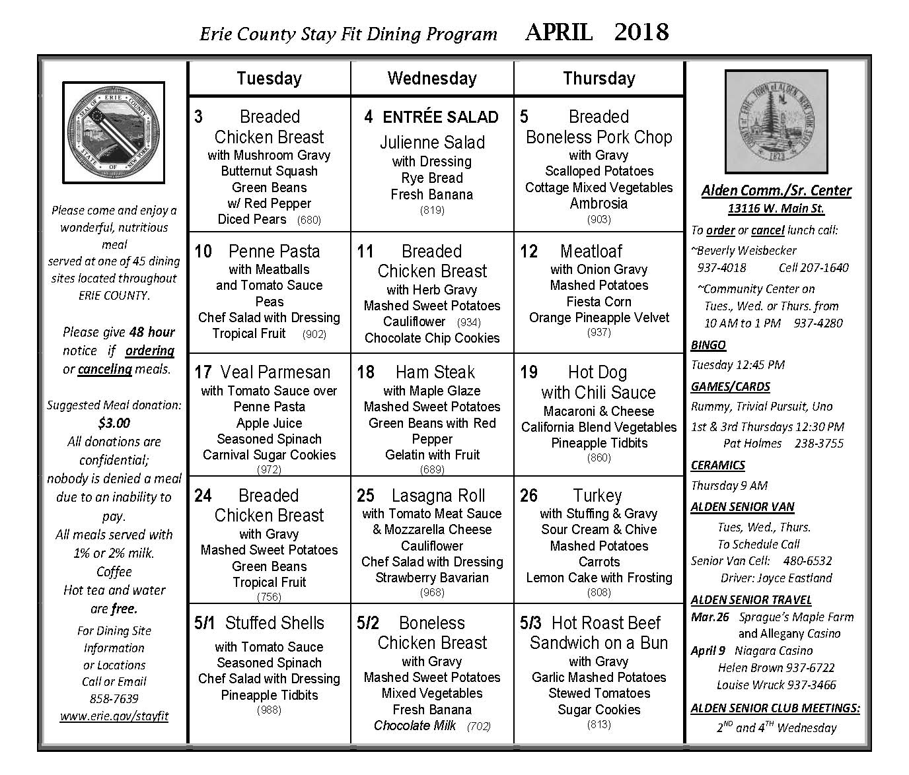
Senior News
April 11 Member meeting @ 1:00pm - Community Center. Sign-in begins at 12:30pm.
April 24 Executive meeting @ 9:30am - Community Center.
April 25 Member meeting @ 1:00pm - Community center. Sign-in begins as 12:30pm April Birthday celebration with cake and ice cream.
Save the date: Member Spring Luncheon on Monday, May 7 - watch the Alden Advertiser for details after April 6.
Answer to Alden History Quiz: (b) The town was first settled by Moses Fenno in 1810, who located in the spring, and was followed in the same year by Joseph Freeman, William Snow, John Estabrook and Arunah Hibbard, each of whom built a log house near the site of Alden village. During the war of 1812 many settlers left the town, but returned in the spring of 1814, and in that year John C. Rogers built the first saw mill in the town on Ellicott Creek at the site of Alden Center.

