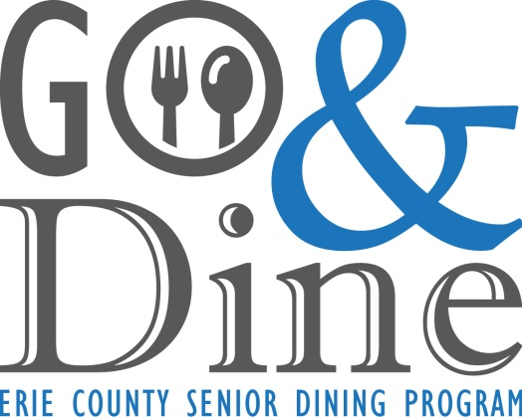
Mark Poloncarz
COUNTY EXECUTIVE

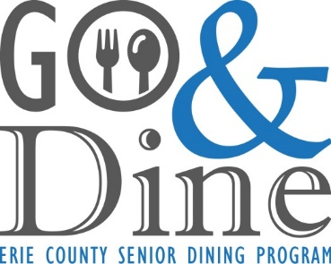 Erie County Senior Services
GO & DINE program guidelines
1. Participants must be 60 years or older, and a resident of Erie County.
2. A registration form must be FULLY COMPLETED by the participant in order to participate in the Go & Dine Restaurant Program.
3. The costs of the approved meals are covered by Erie County. All gratuities and costs of any additional menu are the responsibility of the participant.
4. Meals are normally required to be consumed at the restaurant. However, due to Covid-19, take-out is allowed, but limited to one meal per person, per day. Leftovers may be taken home.
5. The meal is for the participant of the Go & Dine Program only. Participants may NOT use their vouchers to cover any meal other than their own. Participants who are caught violating this policy will be removed from the program.
6. Participants are required to present both their assigned key tag and voucher at the beginning of each dining experience.
7. Participants will be asked to answer short surveys about the program, full participation in these surveys is encouraged so that we may improve and maintain the program.
8. Vouchers for meals will be sent monthly. With each monthly supply of vouchers, participants will also receive nutritional education information as well as a self-addressed envelope to send in a voluntary contribution. These contributions will help sustain the program. Contribution should be made by check. DO NOT SEND CASH. Please make the check payable to the Erie County Department of Senior Services, and put Go & Dine in the memo.

West Side Bazaar
25 Grant Street (corner of Grant and Ferry)
Buffalo, NY 14213
(Parking in lot off of West Ferry)

HOURS:
Tuesday-Thursday: 11am – 7pm
Friday & Saturday: 11am – 8pm
Sunday & Monday: Closed

VENDORS (3)
**All meals come with milk and dessert du jour

Abyssinia Ethiopian Cuisine – (716) 563-6602
Senior Veggie Combo – Veggie Combo, with Beets, Lentils, Split Peas, Stewed Spinach, Cabbage, Potato, Carrots, Green Beans, Injera or Rice
Senior Abyssinia Combo – Chicken or Beef with Veggies and Hard-Boiled Egg, Injera or Rice
Gufuma – Ethiopian Spices, Corkscrew Pasta, Red and Green Peppers, Onions, and Choice of Chicken or Beef

Thang’s Family Japanese Ramen – (716) 715-5053
Vegetable Ramen – Miso, Bok Choy, Napa Cabbage, Mushroom, Broccoli, Carrot, Bean Sprouts, Zucchini, Yellow Squash, Snow Peas, Ramen
Yaki Udon – Buckwheat Noodles stir fried with Chicken, Octopus, Squid, Prawns, Egg, Snow Peas, Carrots, Onion, Sesame Seeds, Yaki Sauce
Senior Katsu Ramen – Fried Chicken, Ramen, Chives, Mushrooms, Egg, Milk, Scallions, Sesame Seeds, Special Sauce

007 Chinese Food – (716) 951-2535
007 Dim Sum Combo 1 – Char Siu Pau (bbq pork steam bun), Shumai (pork, shrimp, carrot dumplings), Black Bean Bau (black bean paste steam bun)
007 Dim Sum Combo 2 – Sayo Pau (jicama, carrot, mushroom steam bun), Corn-O Dumpling (corn, shrimp pork), Sweet Pea Dumpling (sweet pea, shrimp, pork)

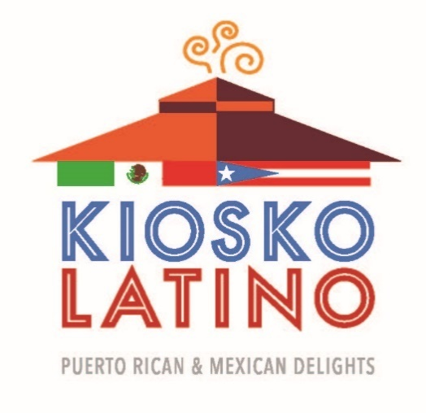
Kiosko Latino (formerly at West Side Bazaar)
345 W Ferry St
Buffalo, NY 14213
(716) 424-2000

Hours:
Tuesday – Thursday: 11:30am – 6pm
Friday & Saturday: 11:30am – 7pm
Sunday & Monday: Closed

Lunch & Dinner
Senior Pernil or Pollo Guisado – Roasted Pork or Chicken with Rice and small Side Salad
Enchilada Combo – White Corn Tortilla, Sauce, Cheese, choice of protein (beef/chicken/pork), Refried Beans with Rice and a small Side Salad
Three Taco Combo – Mexican Rice with three Rolled Tacos, Beef, Refried Beans, and small Side Salad
**All meals come with milk and dessert du jour

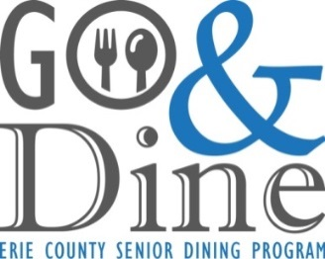
Fuji Grill Japanese Restaurant
736 Maple Road
Williamsville, New York
(716) 688-6199

Hours:
Mon – Thurs: 11am – 10pm
Fri – Sat: 11am – 11pm
Sunday: Noon – 10pm

Lunch/Dinner
BENTO BOX

Choice of One: Beef, Chicken, Salmon, Shrimp, or Tofu
Choice of Sauce: Teriyaki, Spicy, or Plain
with Assorted Stir-Fry Vegetables

Served With:

Seasoned White Rice
Shumai (Dumpling)
Edamame
Green Salad with Homemade Ginger Dressing
Milk
Mochi Ice Cream (Assorted Flavors)

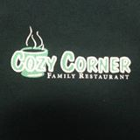
Cozy Corner
690 East Main Street
Springville, NY 14141
(716) 592-9545

Hours:
Monday – Thursday: 6am – 2pm
Friday: 6am – 8pm
Saturday: 6am – 2pm
Sunday: 8am – 2pm

Breakfast (No breakfast after 11am on FRIDAYS):
2 Eggs – Cooked to your liking, with Bacon, Toast, Home Fries
2 Pancakes – served with Syrup, Bacon, Home Fries
2 Egg Vegetable Omelet – with Cheese, Mushroom, Tomato, Onion, Green Pepper, and served with Home Fries, Toast

Lunch & Dinner
Cozy Cheeseburger – with Macaroni Salad or Coleslaw
Soup and half Sandwich – (ham, turkey, salami or bologna)
Tuna Melt – with Macaroni Salad or Coleslaw
Grilled Ham & Cheese – with Macaroni Salad or Coleslaw
Greek Chicken Salad
Julienne Salad
Cold Plate – Macaroni Salad, Potato Salad, Coleslaw, Meat and Cheese
Liver and Onions – with Mashed Potatoes and Gravy, a side Salad and Bread
Ham Steak – with Mashed Potatoes and Gravy, a Side Salad and Bread
Open Meatloaf – with Mashed Potato and Gravy, side Salad, and Bread

**All meals come with milk and dessert du jour

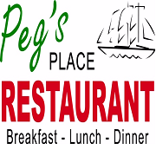
Peg’s Place
4046 Lake Shore Rd
Hamburg, NY 14075
(716) 627-7800

Hours:
Monday – Saturday: 7am – 8pm
Sunday: 7am – 2pm

Breakfast
2 Eggs – cooked to your liking with your choice of Ham, Bacon or Sausage, Toast, Home Fries, Juice, Apple Sauce
1 Waffle – served with Syrup, your choice of Ham, Bacon or Sausage, Toast, Home Fries, Juice, Apple Sauce
2 Egg Vegetable Omelet – with Cheese, Mushroom, Tomato, Onion, Green Pepper and served with Apple Sauce, Home Fries and Toast
Lunch & Dinner
1/4 Pound Burger – with Cheese, Lettuce, Tomato, Onion; Potato Salad
Roasted Turkey Breast – on a Pita or Wrap with Lettuce, Tomato, Onion; Cup of Soup
Tuna or Egg Salad – on Toast with Lettuce and Tomato; Cup of Soup or Chili; Applesauce
Chicken or Steak Souvlaki – served with Pita Bread
Chef Salad – served with Grilled Chicken
Bourbon Chicken – served with Mashed Potato and Vegetable Medley, Bread
Salisbury Steak – with Mashed Potato, Vegetable, Bread
Liver and Onions – with Baked or Mashed Potato, Vegetable, Dinner Roll
Spaghetti and Meatballs – served with side Salad, Breadstick

**All meals come with milk and dessert du jour

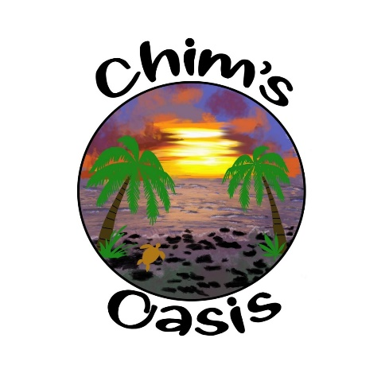
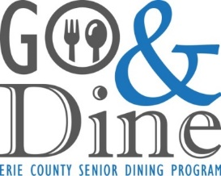

38 Niagara St.
Tonawanda, New York
(716) 692-2700

Hours:
Wednesday – Sunday: 7am – 2pm

Breakfast
(No Substitutions)
All meals served come with a fruit cup and 1% milk

(2) Eggs Special – with Home Fries, (2) Bacon or Sausage, choice of Toast, OJ

(2) Slices of French Toast – served with (2) Bacon or Sausage, OJ

Egg & Cheese Sandwich – Ham, Bacon or Sausage on your choice of bread, side of Home Fries, OJ

Fiesta Scramble – (2) Eggs scrambled with Cheddar Cheese, Homemade Salsa, Home Fries, Sour Cream on the side, OJ

Lunch
(No Substitutions)
All meals served come with Salad of the day, Cookie & 1% milk

Tiki Turkey – Turkey Breast, Lettuce, Tomato, Onion, Provolone & Mango Chutney, on your choice of Bread

Cup of Soup & Grilled Cheese – Beach Bum Grilled Cheese and a Cup of our Soup du jour (ask for soup choices)

Bacon Cheddar Burger – with Lettuce, Tomato & Onion on a Kaiser Roll

Chicken Souvlaki – Marinated Chicken, Lettuce, Tomato, Onion, Feta Cheese & Greek Dressing served on warm Pita

Salad of the Day
Tuna Mac salad
Mayo based salad with carrot, onion, celery, egg & tuna
Potato Salad
Mayo based salad with carrot, onion and celery

Call ahead with order (716) 692-2700

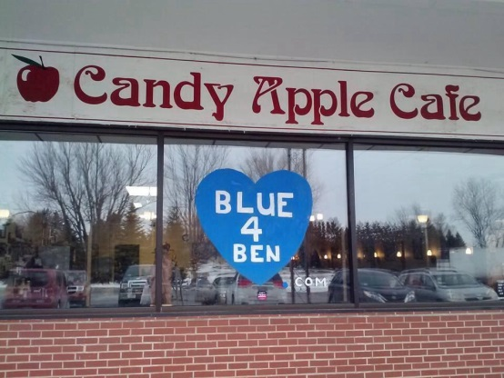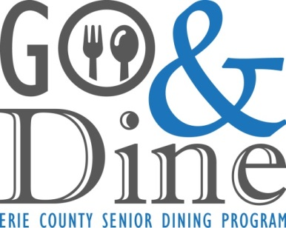
Candy Apple Cafe
81 Buell St.
Akron, New York 14001
(716) 542-4155

Hours:

Open Everyday
7am-7pm

Breakfast
(2) Eggs any style – with Home Fries, (2) Bacon or Sausage, Toast, small Orange Juice, small 1% Milk, and Fresh Fruit or Apple Sauce

Vegetable Omelet (tomato, onion, mushroom, pepper, broccoli, & cauliflower) – Home Fries, small Orange Juice, small 1% Milk, and Fresh Fruit or Applesauce

Western Breakfast Sandwich on a Hard Roll – Home Fries, small Orange Juice, small 1% Milk, and Fresh Fruit or Applesauce

(2) Pancakes with – Your choice of Ham, Bacon or Sausage, Home Fries, small Orange Juice, small 1% Milk, and Fresh Fruit or Applesauce

Lunch/Dinner
Little Ben’s Big Burger – w/Lettuce, Tomato, Onion, Potato Salad, small 1% Milk, & Cookie

Cheryl’s Favorite Pita Pocket (choice of Tuna, Chicken or Roast Beef) –w/Lettuce, Tomato & Onion, Coleslaw, small 1% Milk, & Cookie

Tuna or Chicken Salad Plate – w/Cottage Cheese, Egg, Cucumber, Chef Salad, & Dressing, small 1% Milk, & Cookie

Homemade Meatloaf – w/Mashed Potato & Gravy, Vegetables du Jour, Roll w/Butter, small 1% Milk, & Cookie

Baked Chicken Parmesan – w/Pasta & Tomato Sauce, Vegetable du Jour, Chef Salad w/Dressing, small 1% Milk, & Cookie

Country Grilled Ham Steak – w/Baked Potato, Vegetable du Jour, Roll w/Butter, small 1% Milk, & Cookie

Sautéed Liver & Onions – w/Mashed Potatoes & Gravy, Vegetable du Jour, Roll w/Butter, small 1% Milk & Cookie

17 Main Street
Hamburg, New York 14075
(716) 648-5779

HOURS:
Sunday: 9:00am – 3:00pm
Mon. – Sat.: 8:00am – 7:00 pm

Breakfast
Includes: tropical fruit and milk

Quiche – crustless cheesy egg casserole, side of toast, choice of ham, bacon, or sausage and 100% juice

Oatmeal & Yogurt – served with milk and brown sugar and a side of low-fat vanilla yogurt with mixed berries

Vegetarian Breakfast Scramble – egg, peppers, onion, hash brown, cheese, side of toast

Western Omelet – egg, ham, salsa, fried onion, roasted red pepper and cheddar cheese, side of toast

Cheese Omelet – egg with melted cheese, side of toast and 100% juice

Bacon Mushroom Omelet – egg, crumbled bacon, sautéed mushrooms, Swiss cheese, side of toast

Lunch/Dinner
Includes: tropical fruit, milk and your choice of a cup of soup or side salad

Chicken Club Wrap - chicken breast, bacon crumbles, lettuce, tomato, ranch dressing

Deluxe Tuna Wrap – tuna salad, cheddar cheese, roasted red peppers, spinach

LTM Panini - lettuce, tomato, mayo, choice of turkey/ham/or tuna salad

Three Cheese Panini - cheddar, American, and Swiss cheese grilled together

Veggie Delight Panini – avocado, roasted red pepper, tomato, spinach, red onion, cheddar cheese

Comfort Caprese Melt – mozzarella, tomato, pesto mayo, balsamic glaze

Swiss Florentine Quiche – crustless baked egg casserole topped with fresh spinach and Swiss cheese

Tomato and Cheddar Quiche – crustless baked egg casserole topped with cheddar cheese and tomato

Salads
Includes: tropical fruit, milk and your choice of a cup of soup or Deep River chips

Mediterranean Delight – mixed greens, banana peppers, black olives, chick peas, feta cheese, sundried tomato basil vinaigrette

CZ Indulgence Salad – mixed greens, chicken breast, cheddar cheese, walnuts, craisins, mandarin oranges, croutons, sweet and sour Riviera dressing

